Elizabeth Shen

402 HW Assignment 2

Problem 5.1, Stephens page 116

What's the difference between a component-based architecture and a service-oriented architecture?

A component-based architecture shows the system to be components that provide services for each other. A service-oriented architecture portrays the systems to have the pieces are implemented as services, often running on separate computers communicating across a network. The pieces are more separated in a service-oriented architecture.

Problem 5.2, Stephens page 116

Suppose you're building a phone application that lets you play tic-tac-toe against a simple computer opponent. It will display high scores stored on the phone, not in an external database. Which architectures would be most appropriate and why?

There wouldn’t be any need for remote services or database since the game it is just a simple mobile game. For the same reason, there wouldn’t be any need for a component based, client-server, or multitier architecture. Since it’s a small appliccation, a monolithic architecture would be a good choice. It would also be a good idea for it to be a rule-based (data-centric) application to build tables for the moves of the game.

Problem 5.4, Stephens page 116

Repeat question 3 [after thinking about it; it repeats question 2 for a chess game] assuming the chess program lets two users play against each other over an Internet connection.

Since the program would now need to exchange information across the internet, the application would best be built as a monolithic rule-based service-oriented application.

Problem 5.6, Stephens page 116

What kind of database structure and maintenance should the ClassyDraw application use?

The ClassyDraw application would not need a database since the drawings can each be stored in separate files. Operating system tools can help the user manage the files. For example, the application would have a temporary file when the user is editing, and the user would be able to save them as they wish.

Problem 5.8, Stephens page 116

Draw a state machine diagram to let a program read floating point numbers in scientific notation as in +37 or -12.3e+17 (which means -12.3 x 1017). Allow both E and e for the exponent symbol. [Jeez, is this like Dr. Dorin's DFAs, or *what*???]

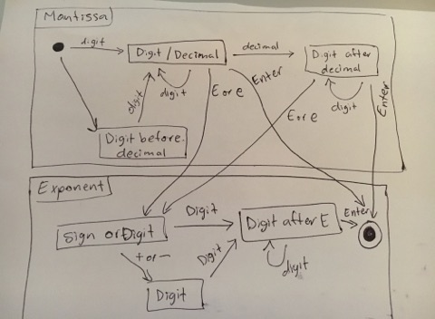

Problem 6.1, Stephens page 138

Consider the ClassyDraw classes Line, Rectangle, Ellipse, Star, and Text. What properties do these classes all share? What properties do they not share?

Are there any properties shared by some classes and not others? Where should the shared and nonshared properties be implemented?

The classes all share properties that are needed for drawing, such as foreground color and background color. They do not all share the font property (only Text would have this). The Star class would need to know the number of points that a star would have

Some properties shared by some classes and not others would be fill color for only shapes that can be filled (Rectangle, Ellipse, Star), and line properties for the Classes that draw lines. For example, line thickness and dash style would be properties shared by Line, Rectangle, Ellipse, and Star.

Problem 6.2, Stephens page 138

Draw an inheritance diagram showing the properties you identified for Exercise 1. (Create parent classes as needed, and don't forget the Drawable class at the top.)

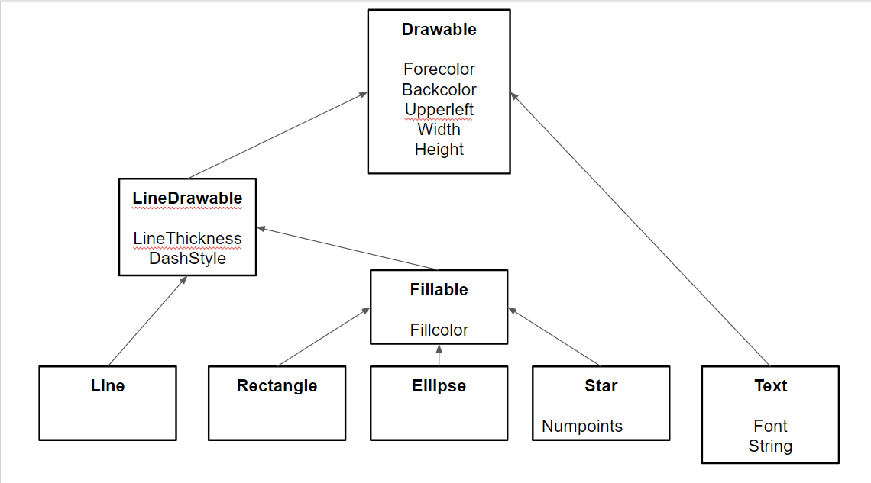

Problem 6.3, Stephens page 139

The following list gives the properties of several business-oriented classes.

* Customer — Name, Phone, Address, BillingAddress, CustomerID
* Hourly — Name, Phone, Address, EmployeeID, HourlyRate
* Manager — Name, Phone, Address, EmployeeID, Office, Salary, Boss, Employees
* Salaried — Name, Phone, Address, EmployeeID, Office, Salary, Boss
* Supplier — Name, Phone, Address, Products, SupplierID
* VicePresident — Name, Phone, Address, EmployeeID, Office, Salary, Managers

Assuming a Supplier is someone who supplies products for your business, draw an inheritance diagram showing the relationships among these classes. (Hint: Add extra classes if necessary.)

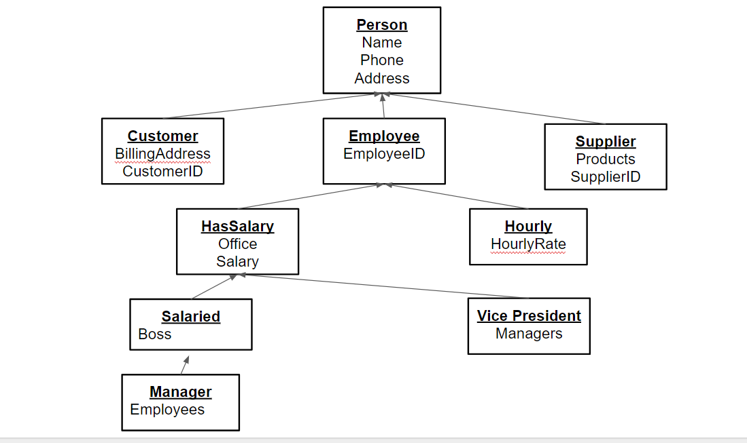

Problem 6.6, Stephens page 139

Suppose your company has many managerial types such as department namager, project manager, and division manager. You also have multiple levels of vice president, some of whom reprt to other manager types. How could you combine the Salaried, Manager, and VicePresident types you used in Exercise 3? Draw the new inheritance hierarchy.

You could combine these types by having a salaried class for the managerial positions, and a separate hourly class for hourly employees. There would also be a boss property and an employees property. The boss property would be for those who do not have to report to someone on a regular basis, and the employees property (would be empty for those who do not manage or oversee anyone else).

